Additive White Gaussian Noise

The awgnGen module adds AWGN to an incoming signal array. The awgn is simulated by a single, i.i.d. Gaussian random process. The numpy.random module provides a Gaussian distributed random number generator. The awgnGen.__init__ method requires the anticipated period and samples per period of an incoming array to set up an instance. It also requires the desired power of the AWGN. The awgnGen.run method generates an array of random numbers and adds them to the signal. Five plots of the output of the awgnGen.run method are shown in the figure below at varying SNR values.

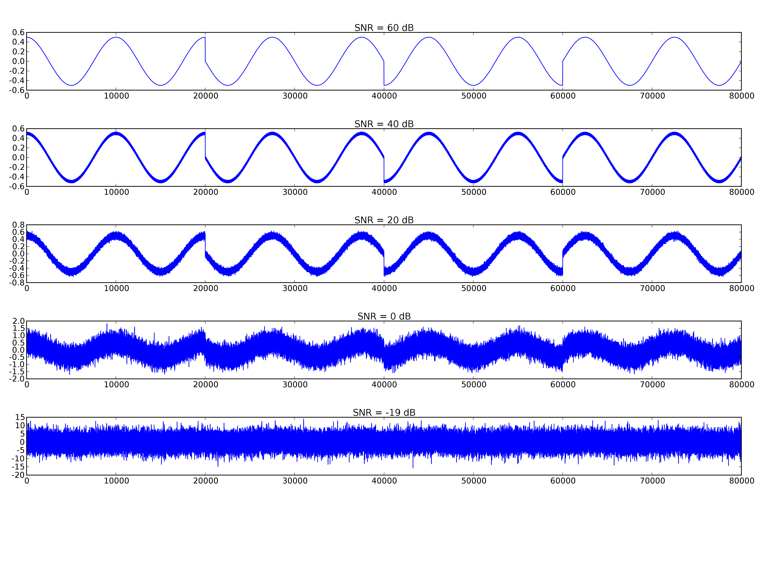Fig. 1: Output of the awgnGen.run method for varying noise power settings.
Usage:

from awgn import *
awgninstance = awgn(period, samplesperperiod, power)
outputarray = awgninstance.run(inputarray, plot = False)

period: The symbol period of the expected signal inputs
power: The average power of the awgn.
samplesperperiod: The number of samples in each symbol period
inputarray: An incoming signal array
outputarray: An outgoing signal array, corrupted by AWGN

